**ON-THE-JOB TRAINING NARRATIVE REPORT**

A Report

Submitted to the Faculty of

**ROMBLON STATE UNIVERSITY**

Cajidiocan Campus

Cajidiocan, Romblon

In Partial Fulfillment

Of the requirements for the degree

**BACHELOR OF SCIENCE IN INFORMATION TECHNOLOGY**

By:

Artz A. Rase

June 2022

# APPROVAL SHEET

This On-the-Job Training was prepared and submitted by Artz A. Rase in partial fulfilment of the requirements for the degree of Bachelor of Science in Information Technology has been examined and recommended for acceptance and approval.

Recommending Approval:

**Inst. RODEL D. BACUNA**

Chairperson – ITDepartment

____________________________________________________________

Accepted and approved in partial fulfilment of the requirements in the course IT 25 with the rating of _____.

Noted by:

**PROF. CHITO F. JUANZO**

Chairperson of Faculty and Instruction

Approved by:

**CARMELINDA M. JUANZO, Ph. D.**

Campus Director

Name: Artz A. Rase

Course: BSIT- IV

|  |  |  |  |  |
| --- | --- | --- | --- | --- |
| AGENCY | No. of Hours  Rendered | Rating | % | Final Rating |
| RSU - Cajidiocan | 520 Hours |  |  |  |
|  |  |  |  |  |
|  |  |  |  |  |
|  |  |  |  |  |
|  |  |  |  |  |
|  |  |  |  |  |
| OVER ALL RATING | 520 Hours |  |  |  |

Approved By:

**CARMELINDA M. JUANZO, Ph. D.**

Campus Director

# ACKNOWLEDGEMENT

With deepest gratitude and appreciation, I humbly give thanks the people who, with all they can, helped me in making my On-the-job Training a possible one.

To my parents, for their unending love and support, for providing all my needs financially and morally, for their patience and understanding during my tiring days that I can’t help them in the chores, for their never fading advices and for being there for me no matter what.

To my sibling who serve as an inspiration to me, who keep on encouraging me to always make the best out of everything and for their being proud and ever supporting brothers to me

To the institution where I am studying, Romblon State University Cajidiocan Campus, where I am continuously growing as a Bachelor in Science in Information Technology and to the instructors for giving us, students, the opportunity to be educated, and keeping on inspiring me to pursue my goals in life. I thank them for their patience during the times that we commit failure and big thanks for touching my life and motivating me to study harder for me to have a better future.

Above all, to our Almighty God for His immeasurable love and for all the blessings He has showered upon me. With all my heart and soul I thank Him for guiding me during my training in this On-The-Job Training. For the provisions and wisdom He has bestowed upon me. For keeping me and my love ones safe. I thank Him for His comfort when I was to give up. By His grace I was able to finish without any conflict.

# DEDICATION

I wholeheartedly dedicate this Internship Report:

To my family and love ones,

To all my friends and classmates,

To all my professors,

And all the faculty at Romblon State University Cajidiocan Campus, and above all, to our Almighty God.

Artz A. Rase

# RSU VISION, MISSION, QUALITY POLICY AND CORE VALUES

# VISION

A research-based higher education institution committed to excellence and service in nurturing globally competitive workforce towards sustainable development.

## MISSION

RSU shall nurture an academic environment that provides advanced education, higher technological expertise in agriculture and fishery, forestry, science and technology, education, arts and sciences, and other relevant fields of study and shall bridge boundaries across other resolutions and communities through responsive, relevant and research-based extension services.

## QUALITY POLICY

Romblon State University commits to provide higher education through quality instruction, research and community extension services that meet or excede the requirements and expectations of the University’s Stakeholder.

It will comply with the international standard, applicable statutory and regulatory requirements and continually improve the Quality Management System’s effectiveness through periodic monitoring and evaluation towards sustained remarkable outcomes.

CORE VALUES

STEWARDSHIP

COMPETENCE

RESILIENCE

BALANCE

EXCELLENCE

SERVICE

These core values SCRIBES serve as our guiding principles in our effort to make ROMBLON STATE UNIVERSITY a recognized HEI in the region and beyond in the coming years.

# GOALS AND OBJECTIVES OF RSU

* To give students guidance and counselling to overcome fright, to increase self-confidence and to value self-esteem.
* To encourage students to express their ideas, feeling, and emotions for better and mutual understanding.
* To train students to lead, to follow, to implement and to safeguard the policies of the University and to appreciate the significance of humility.
* To inculcate in the heart and mind of every student the essence of academic freedom and to guide them on how to exercise such right with valor and pride.

**Table of Contents**

APPROVAL SHEET ii

ACKNOWLEDGEMENT iv

DEDICATION v

RSU VISION, MISSION, QUALITY POLICY AND CORE VALUES vi

VISION vi

MISSION vi

QUALITY POLICY vi

GOALS AND OBJECTIVES OF RSU viii

CHAPTER I 1

INTRODUCTION 1

IMPORTANCE OF OJT 2

OBJECTIVES OF THE PRACTICUM 3

TIME AND PLACE OF THE PRACTICUM 4

CHAPTER II 5

COMPANY PROFILE 5

VISION AND MISSION OF THE COMPANY 9

ACCOMPLISHMENT REPORT 11

NARRATION 12

CHAPTER III 16

APPENDICES 19

APPENDIX A 20

APPENDIX B 21

APPENDIX C 24

APPENDIX D 38

APPENDIX E 39

# CHAPTER I

## INTRODUCTION

On the job-training is an activity wherein the trainees, are given the direct instructions to perform their jobs on the actual workflow. On-the job training has many advantages, and disadvantages if the OJT is not properly planned and executed.

On the-job training formally acquaints the students formally to real life work place environment. This will help them to explore the relationship between the knowledge and skills acquired in college with those required in the working situations. This enable students to understand and respond better to the market demand.

Colleges and universities require the students to undergo on-the job training within a specific number of hours as part of the curriculum. It is the best beginning of greatest educational experiences of BSIT students. Through on the job training BSIT students could develop attitudes, skills and understanding relevant to the field of Information Technology.

## IMPORTANCE OF OJT

1. It is applying, enriching and exchanging the acquired knowledge in the school in their particular field of endeavor.
2. A way of changing student outlook in life through exposure in the performance of actual work that may serve as the stepping stone for the future.
3. It develops interpersonal relationship with other employees within the agency.

## OBJECTIVES OF THE PRACTICUM

* To let the students, feel and experience the actual world and a chance to enhance the development of their skills in the computerized environment.
* To expose the students to the current trends and development in a particular agency or office.
* To broaden the student’s practical experience and their outlook to their line of work to have proper prospective and attitudes.

## TIME AND PLACE OF THE PRACTICUM

The On-the-Job Training was performed during Monday to Friday. This training was undertaken from February 01, 2022 to May 13, 2022 covering the required hours at Romblon State University Cajidiocan Campus, at the Barangay Sugod Cajidiocan Romblon.

# CHAPTER II

## COMPANY PROFILE

**1914:** Tracing its roots back in November 1914, during the district athletic meet in Odiongan, the Odiongan Farm School started only in the imagination when John C. Early, then head teacher of Romblon Sub Province suggested to teachers the idea of the establishment of a farm school in the locality to educate farmers in better farming methods.

**1915-1916:** The Odiongan Farm School came into being in June 1915, with sixty-five pupils enrolled in the fifth grade and forty-eight pupils in the sixth grade. Juan Fetalino, the most promising teacher in the province, took charge of the school as a principal, and was assisted by Felipa Festin, another teacher of long experience in June 1916. A complete farming course for boys, and housekeeping and house course for girls were opened, with an averaged enrollment of forty pupils for each grade.

**1922-1930:** In June 1922, a first year class was started and in June 1927 a second year class was added. The third and fourth year classes were organized in 1929 and in 1930, respectively. The name became Odiongan Rural High School intermediate classes were turned over to the Odiongan Elementary School. The realization of the establishment of the Odiongan Farm School has been largely due to the generosity and enthusiasm of the Odiongan people and through the earnest efforts of John C. Early.

**1947:** In 1947, the Odiongan Rural High School was changed to Odiongan High School that offered a General Type A Curriculum. The demand for change continued to lurk the educational planners of the province.

**1958:** The Odiongan High School was again converted to Odiongan National Agricultural School by virtue of Republic Act No. 1381 and the status remained for some time until the name was changed to Romblon National Agricultural School under General Appropriation Act in 1958.

**1965:** On July 1, 1965, then Congressman Jose D. Moreno of the defunct Congress of the Philippines authored Republic Act No. 4286 converting Romblon National Agricultural School to Romblon National Agricultural College. In the same Appropriations Act, the name Romblon National Agricultural College was shorted to Romblon Agricultural College, however collegiate course were not offered immediately after its conversion due to lack of funds.

**1974:** The year 1974 was the year of fulfillment of the long cherished dream of the people. A two-year Associate in Agricultural Technology (AAT) was offered in compliance Memorandum Circular No.8.s 1974 it has an initial enrollment of twenty-five student (15 male and 10 female).

**1975:** In 1975, three degree courses were offered namely: Bachelor of Science in Agriculture, Bachelor of Science in Agricultural Education, and Bachelor of Science in Home Technology, thus giving more challenges to the college, bringing about positive changes in the life of the people of Romblon. The demand for the higher educational technologies and the quest for relevant education to national development goals are imperative alternatives that could not be ignored by the college authorities.

**1978:** As early as 1978, the plan to convert the Romblon Agricultural College into State College was initiated. The superintendent of the College sought the assistance of the Sangguniang Panlalawigan for endorsement of the Interim Batasan Pambansa. Under the able leadership of Honorable Nemesio V. Ganan, Jr. Assemblyman for Region IV at the same time representing Romblon. He authored Parliamentary Bill 131, an act converting Romblon Agricultural College into Romblon State College and appropriating funds thereof.

**1983:** The Bill was signed into Law on May 18, 1983 by the late President Ferdinand E. Marcos and became Batas Pambasa Blg. 393.

**1998:** With the eagerness to have a University in the Province of Romblon, on September 2, 1998, Atty. Eleandro Jesus Fabic Madrona, Congressman, Lone District of Romblon, filed HB 3265 otherwise known as “An Act Converting the Romblon State College in the Municipality of Odiongan, Province of Romblon, into a State University, to be known as the Romblon State University, Appropriating Funds Therefor, and for other purposes.”

**2001:** Consequently, On January 12, 2001, the Romblon College of Fisheries and Forestry (RCFF) created under Batas Pambansa Blg.553 was integrated to Romblon State College by virtue of BOT Resolution No.3. S.2001 and renamed as RSC Tablas Branch in conformity with IGI-CSI Memorandum order No. 27, S.2001.  Subsequently on February 28, 2001, Sibuyan Polytechnic College (SPC) created by virtue of BP 614 was also integrated to Romblon State College under BOT Resolution No.11, S.2001

and renamed as RSC Sibuyan Branch.

**2009:** October 14, 2009 marked the ultimate dream come true to the Romblomanons when then Pres.Gloria Macapagal Arroyo, an act establishing the ROMBLON STATE UNIVERSITY, signed Republic Act 9721.

## VISION AND MISSION OF THE COMPANY

**VISION**

A research-based higher education institution committed to excellence and service in nurturing globally competitive workforce towards sustainable development solutions.

**MISSION**

RSU shall nurture an academic environment that provides advanced education, higher technological expertise in agriculture and fishery, forestry, science and technology, education, arts and sciences, and other relevant fields of study and shall bridge boundaries across other resolutions and communities through responsive, relevant and research-based extension services.

**QUALITY POLICY**

Romblon State University commits to provide higher education through quality instruction, research and community extension services that meet or exceed the requirements and expectations of University Stakeholders. It will comply with the international standards, applicable statutory and regulatory requirements and continually improve the Quality

Management System’s effectiveness through periodic monitoring and evaluation towards sustained remarkable outcomes.

CORE VALUES:

STEWARDSHIP

COMPETENCE

RESILENCE

INTEGRITY

BALANCE

EXCELLENCE

SERVICE

## ACCOMPLISHMENT REPORT

|  |  |
| --- | --- |
| Week 1  February 01-4 | * Updating computer hardware and Software * Cleaning all computers * Attended orrientation * Checking all computers issue |
| Week 2  February 7-11 | * Installing Anti-Virus * Reformatting all computers |
| Week 3  February 14-18 | * Creating a Layout and Tarpapel * Assisting sir Carabuena * Continuation of Reformat |
| Week 4  February 21 - 25 | * Troubleshooting a no display Desktop * Assisting all Students in their Handson * Creating a Layout in Photoshop |
| Week 5  February 28-March 4 | * Encoding the grade of the student * Checking application of every Computers * Removing malware in Desktop |
| Week 6  March 14-18 | * Resolving Computer issue * Printing Documents * Cleaning the computer laboratory room |
| Week 7  March 21-25 | * Checking a Test Paper * Assisting Students in Computer Programming * Create a Layout for Organizational Chart |
| Week 8  March 28- April 1 | * Cleaning Computer Laboratory room * Continuation of Organization Chart |
| Week 9  April 4-11 | * Maintaining Computers Errors * Checking Other Computers for Technical issue * Cutting and posting tarpapel |
| Week 10  April 18-21 | * Demonstrating of Assemble and Disassemble in BTLED students * Printing a Documents in Agriculture |
| Week 11  April 25-30 | * Setup a new Layout Design in Sir Bacuna Room * Assisting students |
| Week 12  May 2-6 | * Assisting students in their Computer Laboratory * Cleaned and removed stage designs * Reformat a Laptop of a Student |
| Week 13  May 9-13 | * Setting up a LAN Cable network on faculty offices * Assisting students * Checking students test paper |

## NARRATION

Week 1

On the first Day of OJT, Sir Bacuna assign me to Computers Laboratory Room to check all the computers and count how many are in a good condition and working properly.

Week 2

Placing all the computer in a proper place and checking the wire connection, checking all the Application Installed, and also checking all computers that affected by Computer Malware.

Week 3

Create a Layout for Tarpapel that is being used in the event in school and after that sir Carabuena asks for an assistant, and then I continue my reformat that not being finished last week.

Week 4

The continuation of reformat, and there is a Computer Desktop that has no Display I try to troubleshoot that device and yes it success, after that, I start assisting students on their handson in Laboratory, then I start creating a tutorial in photoshop.

Week 5

Sir Carabuena asks me if I'm available to encode every student in his class that has been present or not, after that, I check the Computer that has a Computer Malware or Virus and then try to remove it.

Week 6

Cleaning the Laboratory Room and after that, I check the Desktop that has not been working properly and print some documents for the faculty.

Week 7

Checking a test paper is one of my works this week, after checking a test paper I'm going back in assisting Students in Computer Laboratory, also maam Veron asks me if I'm available this week for Creating a Layout for Organizational Chart, and one of my work this week is creating the Organizational Chart.

Week 8

Cleaning Laboratory, assisting students in their hands-on and the Continuation of the Organizational Layout that not have been finished last week.

Week 9

Maitaining every Computer what I have done this week, checking some minor errors either hardware or software errors, after that, I help my co-ojt in the tarpapel that they made.

Week 10

This week, I'm in front of the BTLED-1 students to demonstrate on how is the proper way to Assemble and Disassemble, after the demonstration that happen in the ma’am Joy Class Room, my co-ojt ask me to assist them in printing documents in the Agriculture office.

Week 11

I create signage in sir Bacuna’s room as he said, I Layout at photoshop, after that work I'm going back again in computer laboratory to assist the students.

Week 12

Assisting Students in their computer Laboratory, and after that, I and my co-ojt students go in stage to remove the Design, and also one of the students ask me to help his Laptop to reformat because of lag and infected of computer virus.

Week 13

This is the last week of OJT a week where all the OJT students are excited before we end this week, we make a LAN cable for a network that is used for the enrollment system that is installed by the main campuses, and I assisting my co-ojt, and then I try to connect every computer thru Local Area Network.

# CHAPTER III

**SUMMARY OF OJT**

It’s been a month since I started my On-the-Job-Training here at Romblon State University Cajidiocan Campus. Far from being a student, my daily routine has been changed into something unusual for me. I have to wake up early in the morning, prepare myself for the long day ahead, and give out the best upon my working hours. I will be working here for 520 hours. And within those five – six days I already learned a lot of things, more than what I expected. I came to realize the importance of on-the-job training to a students’ life. This is where I chose to enhance my knowledge and skills. I am excited but at the same time nervous of what will be my new task. I didn’t have any idea of what kind of task I have to encounter when I start my training there and how should I adjust with the other staff personalities and attitudes. As the days went on I realize that it's a good decision to spent my internship in school because they taught me how to be a better person and employee in the future. It enhance my knowledge about computer skills with the things we do inside the computer laboratory training such as arranging and setting up computer hardware and many more. During my training I learned to be more cooperative to other people.

**REFLECTION**

After the training, I learned that OJT is not just a requirement to be completed but it is an opportunity to show what skills, knowledge and talents that I have and also an opportunity to experience the feeling of being a professional already.

Aside from the experience that I had relating to my course, this OJT allowed to get acquainted with the faculty of ROMBLON STATE UNIVERSITY CC. Being with them is a pleasure because I was working with them. During my stay there as trainee, they kept on encouraging and motivating me to study hard and to do my best always.

I really had a very meaningful and memorable OJT at the RSU-CC. Though I already finished working there as a trainee, I am looking forward to working with them, not as trainee anymore, but professional like them, someday.

# APPENDICES

## APPENDIX A

**(CERTIFICATION)**

## APPENDIX B

**(EVALUATION OF GRADES)**

Name: Artz A. Rase

Course/Year: BSIT - IV

|  |  |  |  |  |
| --- | --- | --- | --- | --- |
| AGENCY | No. of Hours  Rendered | Rating | % | Final Rating |
| RSU - Cajidiocan | 520 Hours |  |  |  |
|  |  |  |  |  |
|  |  |  |  |  |
|  |  |  |  |  |
|  |  |  |  |  |
|  |  |  |  |  |
| OVER ALL RATING | 520 Hours |  |  |  |

Approved by:

**CARMELINDA M. JUANZO, Ph. D.**

Campus Director

Name: Artz A. Rase

Course/Year: BSIT - IV

|  |  |  |  |  |
| --- | --- | --- | --- | --- |
| AGENCY | No. of Hours  Rendered | Rating | % | Final Rating |
| Pre-OJT  RSU | 40 Hours |  | 20% |  |
| RSU - Cajidiocan | 556 Hours |  | 80% |  |
|  |  |  |  |  |
|  |  |  |  |  |
|  |  |  |  |  |
|  |  |  |  |  |
| OVER  ALL RATING |  |  | 100% |  |

Approved by:

**CARMELINDA M. JUANZO, Ph. D.**

Campus Director

## APPENDIX C

**(DOCUMENTATION)**

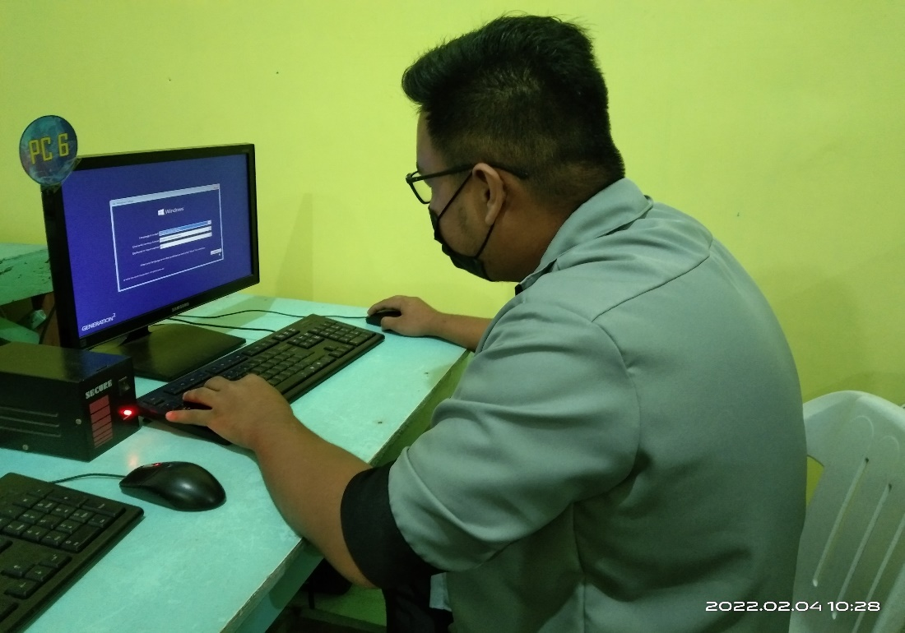

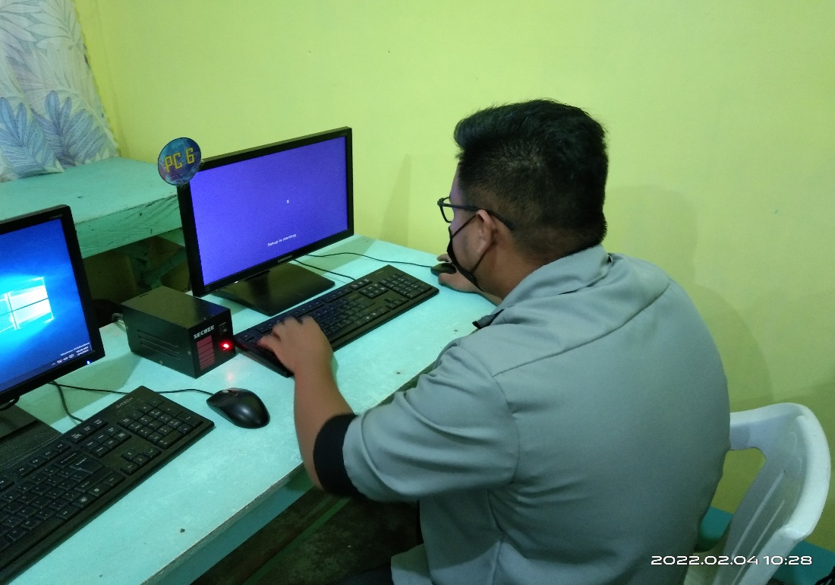

Reformatting a Computers

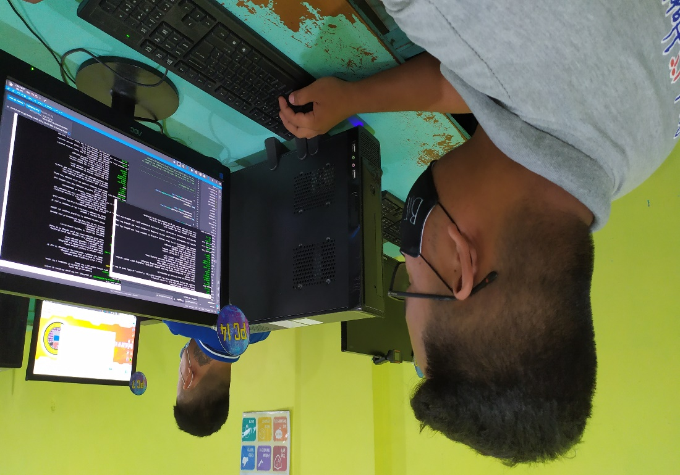

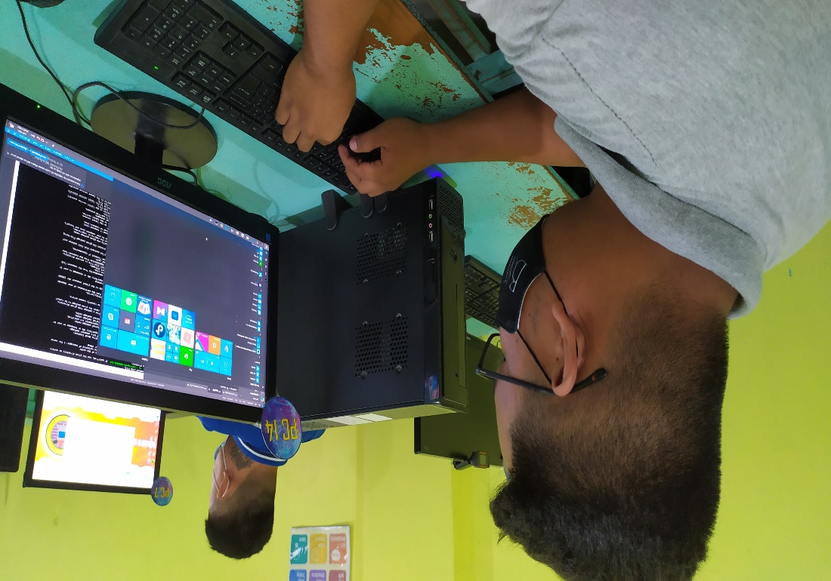

Removing computer malware and checking available software

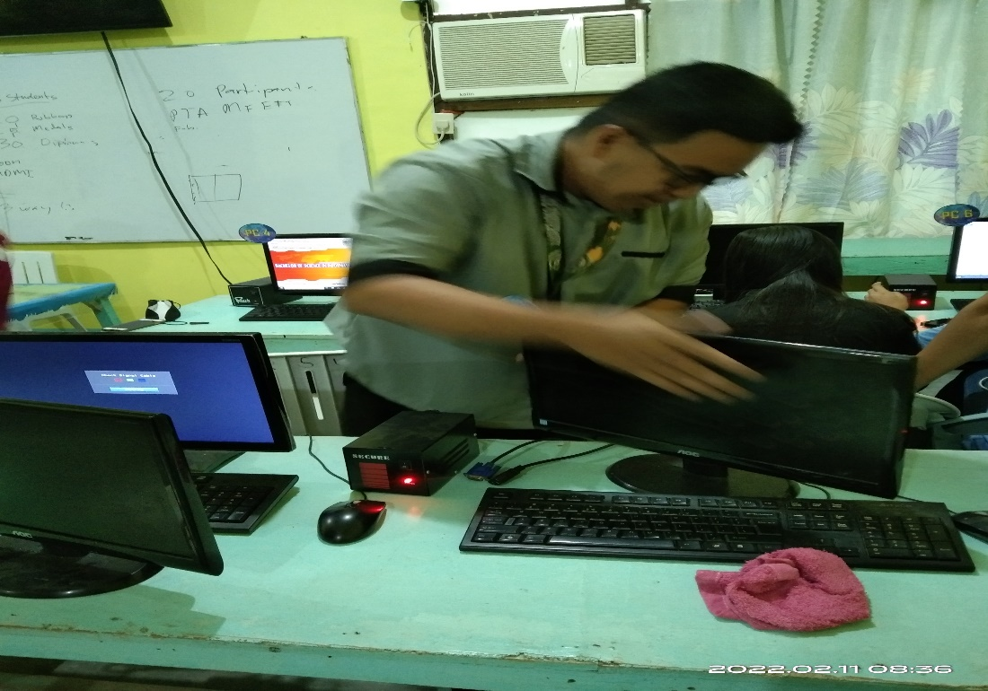

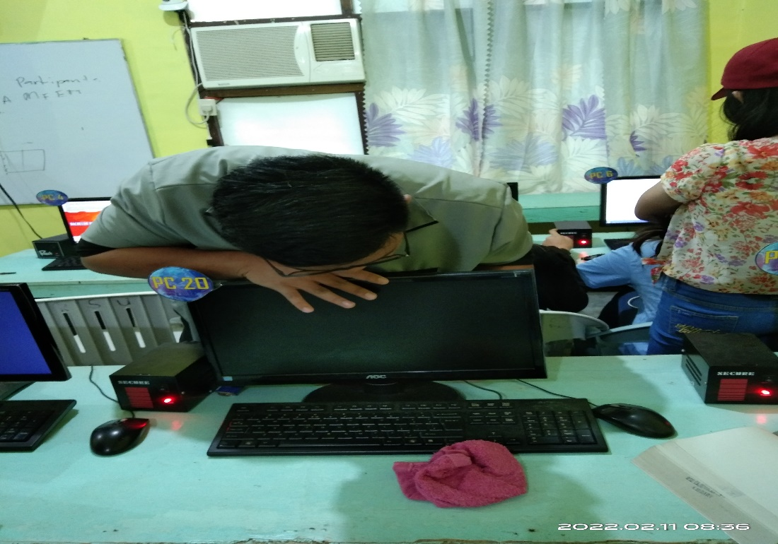

Troubleshooting a no display Computer

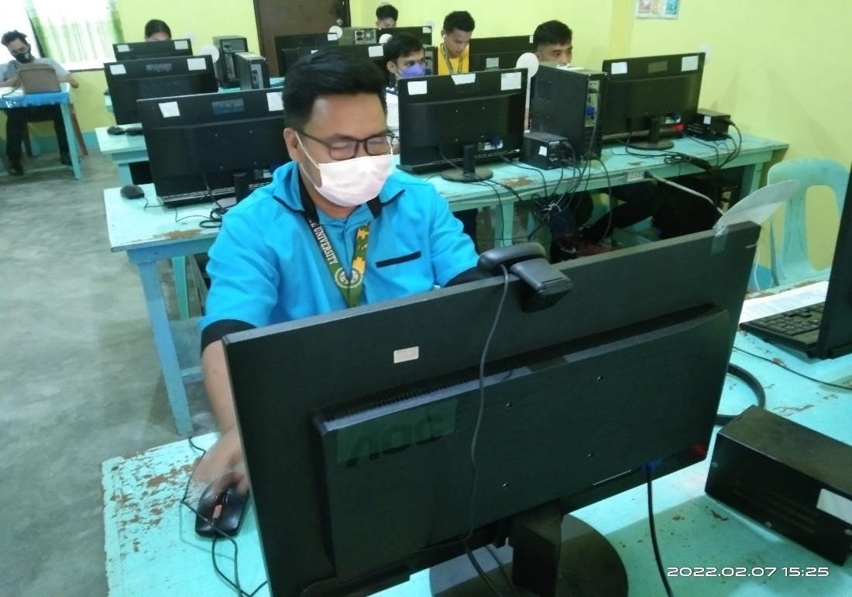

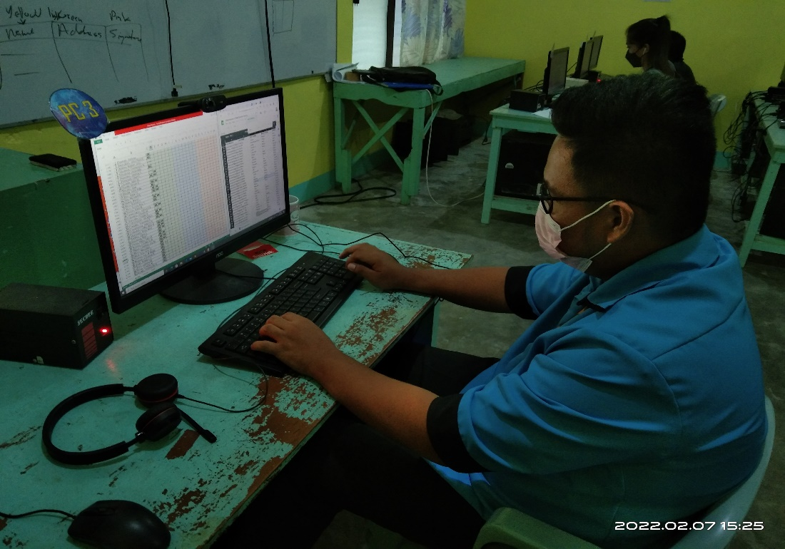

Checking attendance of first-year students

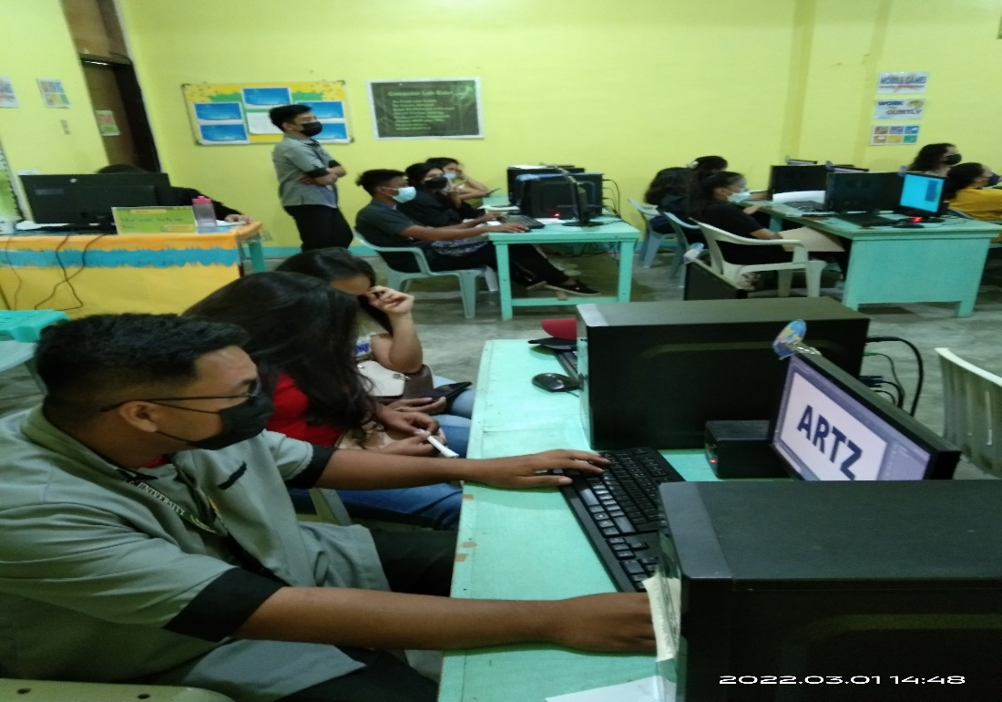

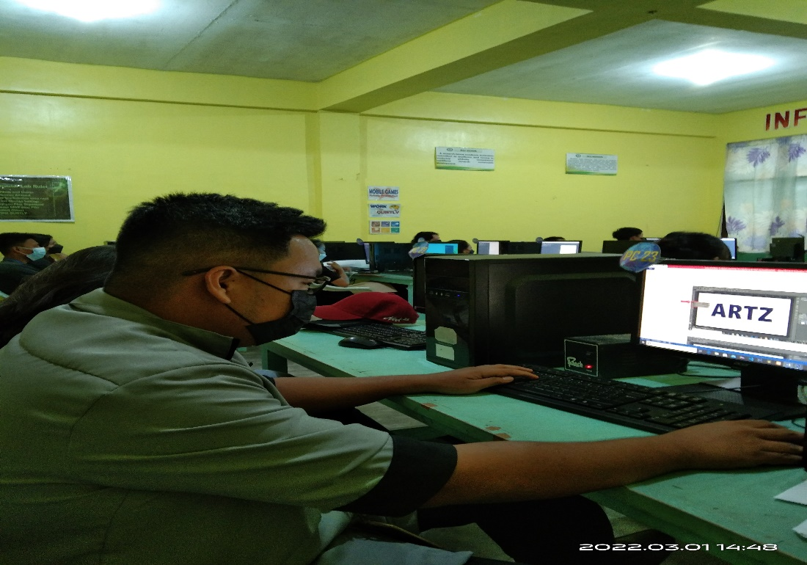

Creating photoshop manual guidelines for 3rd-year students

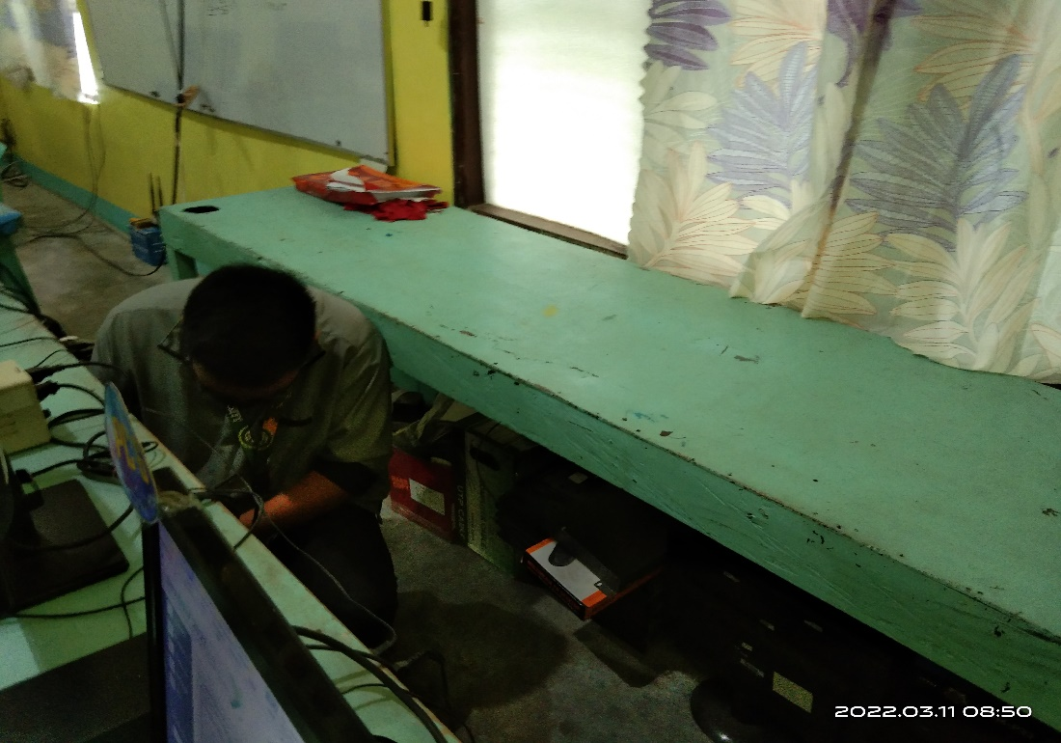

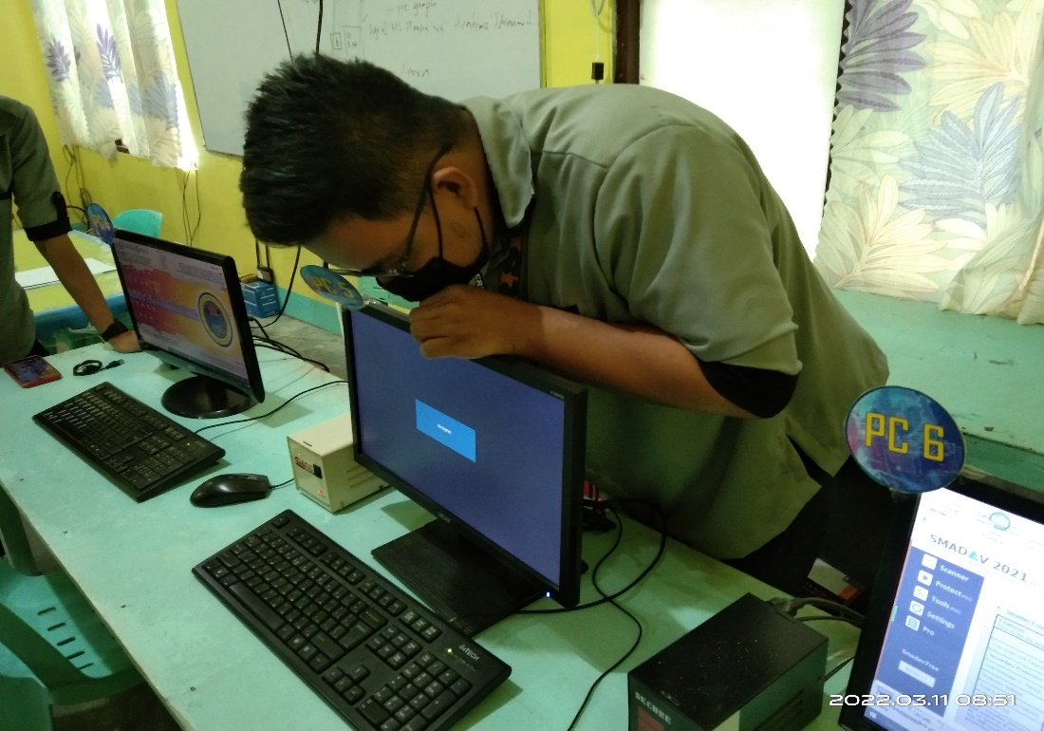

Troubleshooting a system unit

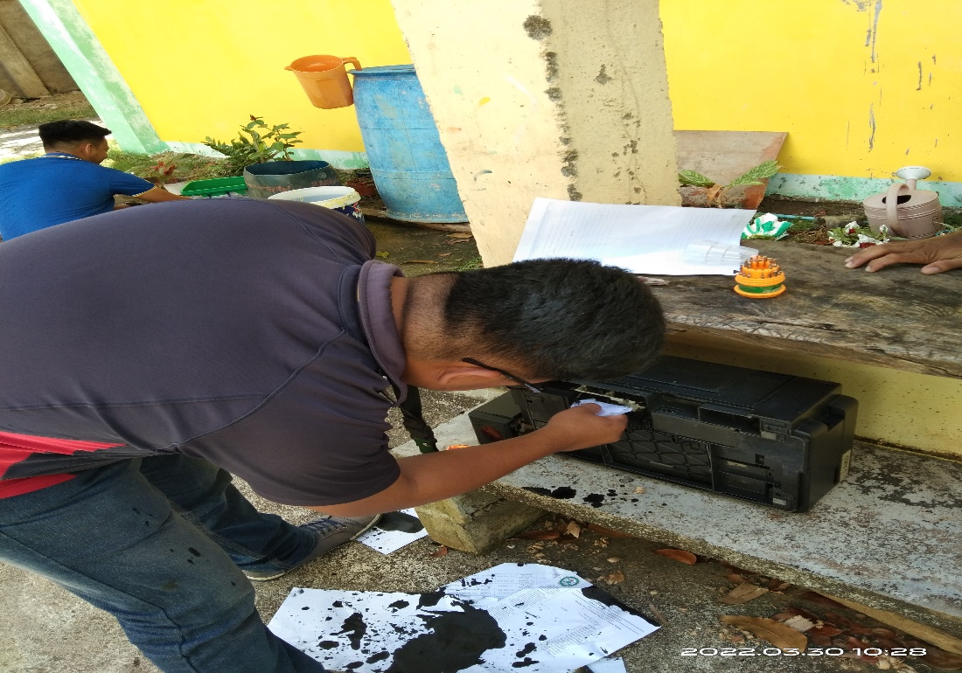

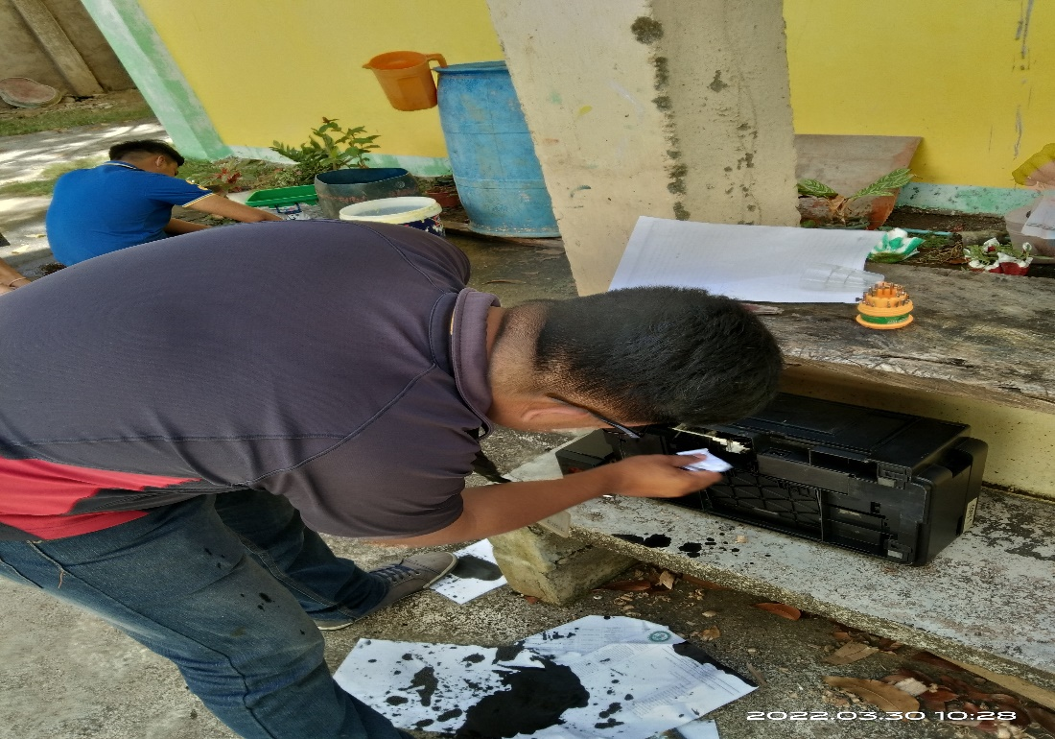

Printer ink cleaning

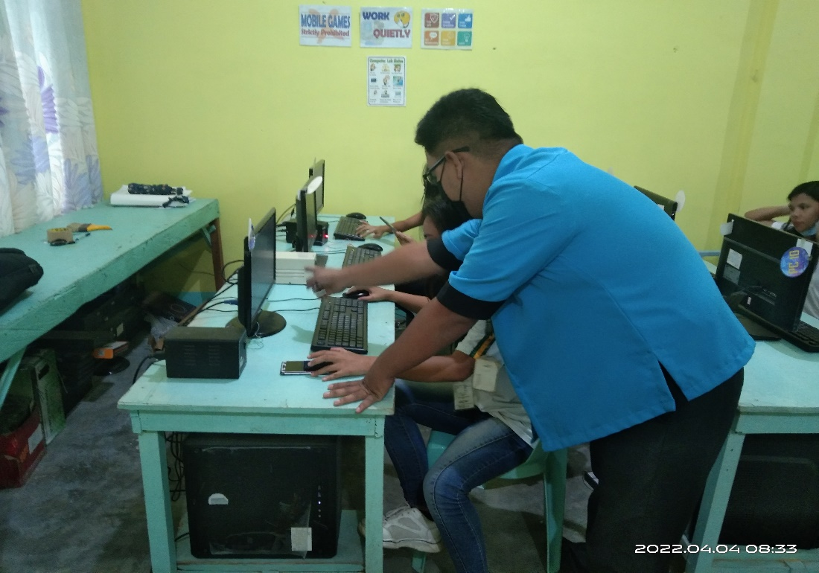

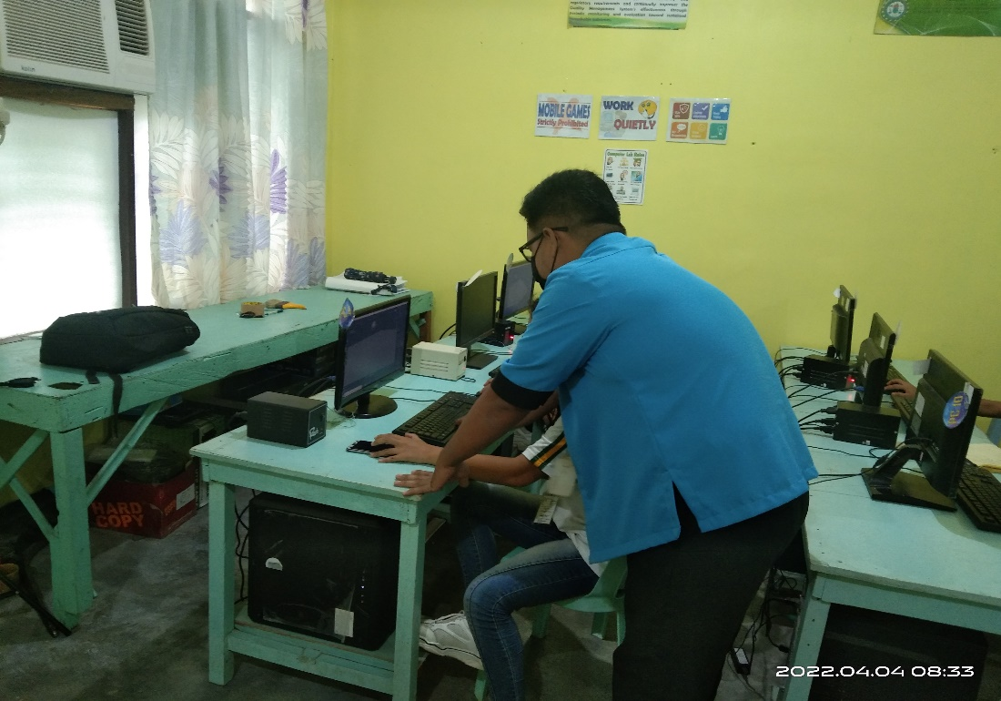

Assisting students during their hands-on

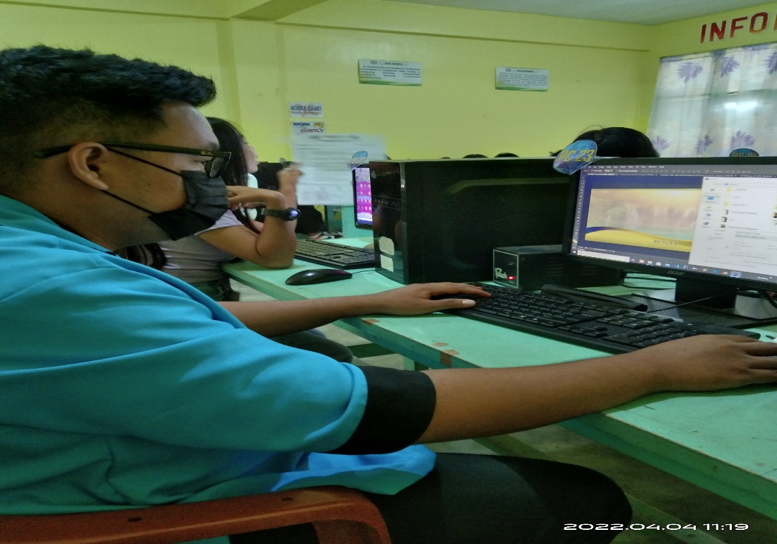

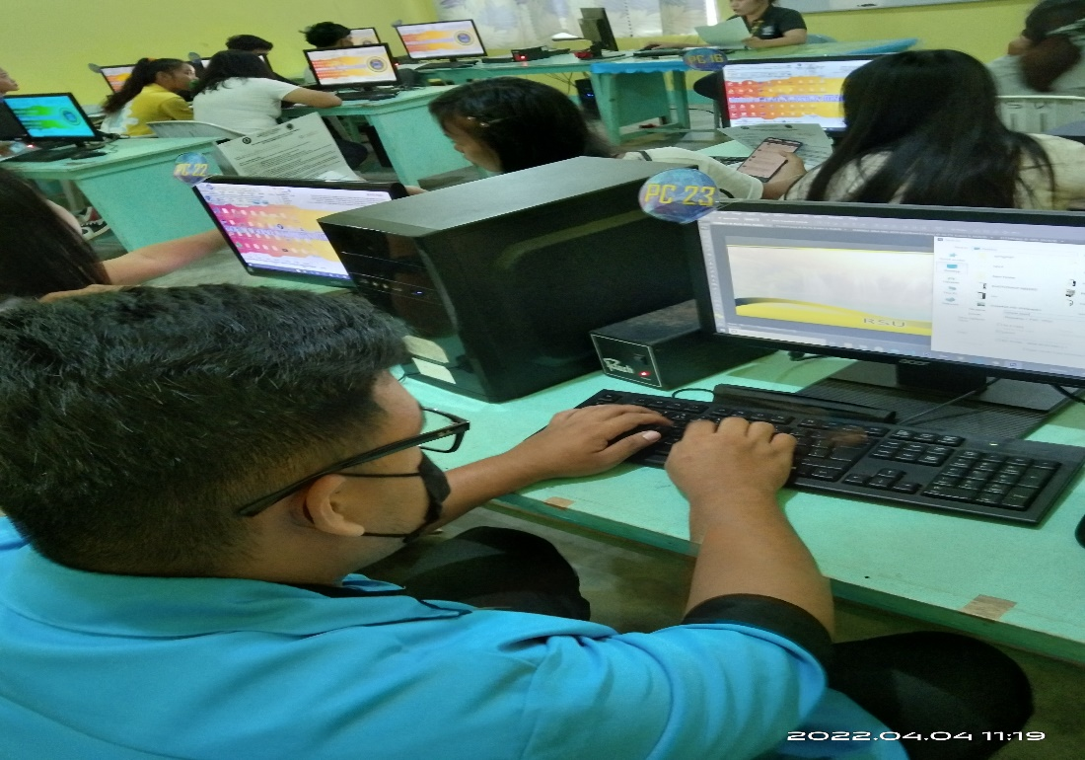

Creating a layout program for the event

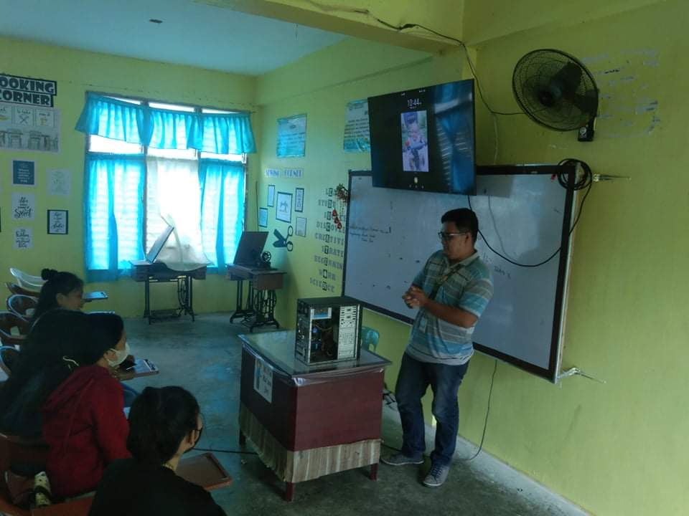

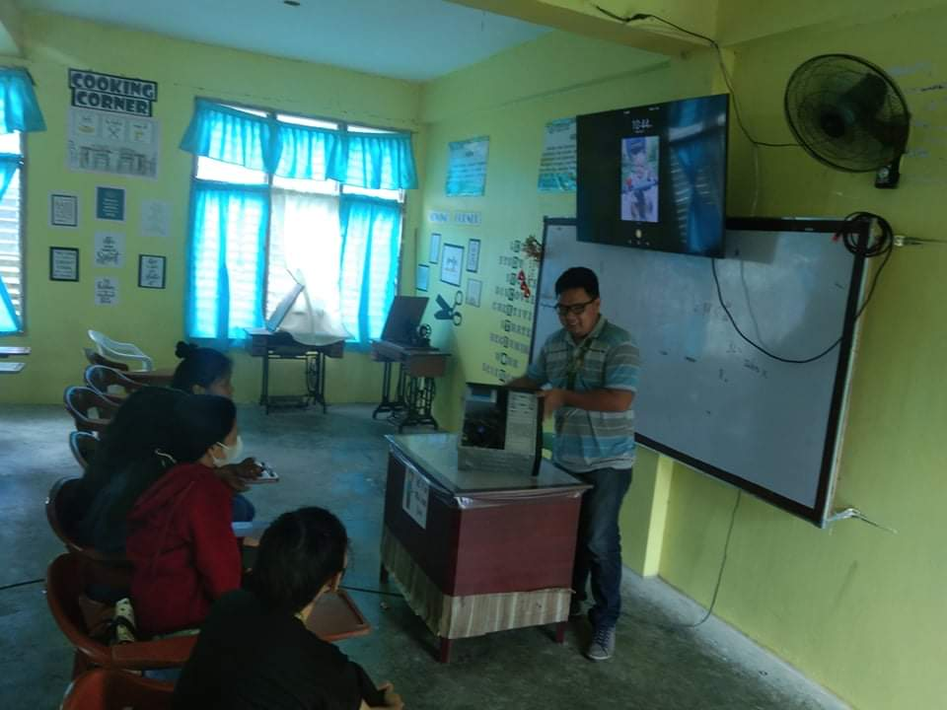

Demonstrate how is the right and proper to assemble and disassemble the system unit.

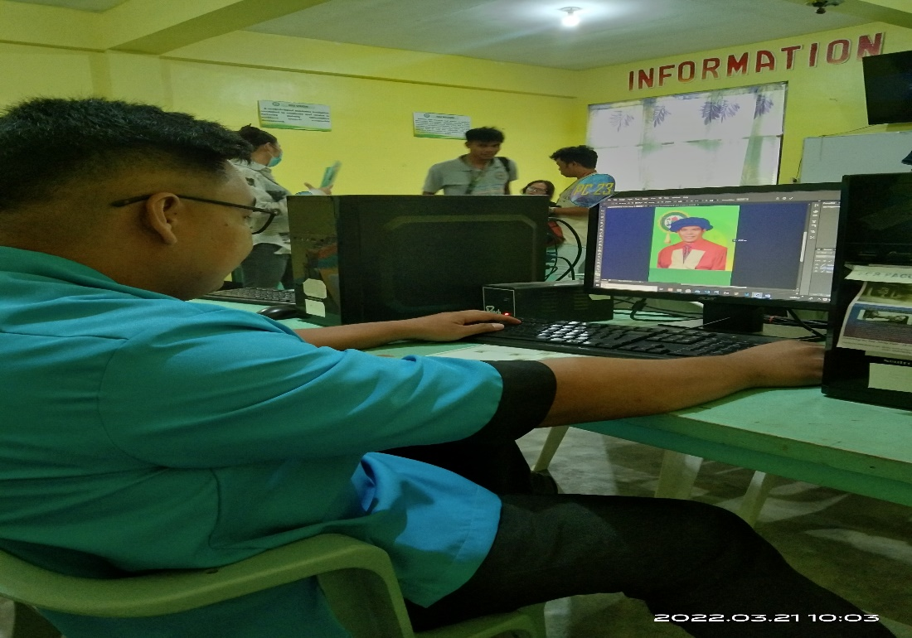

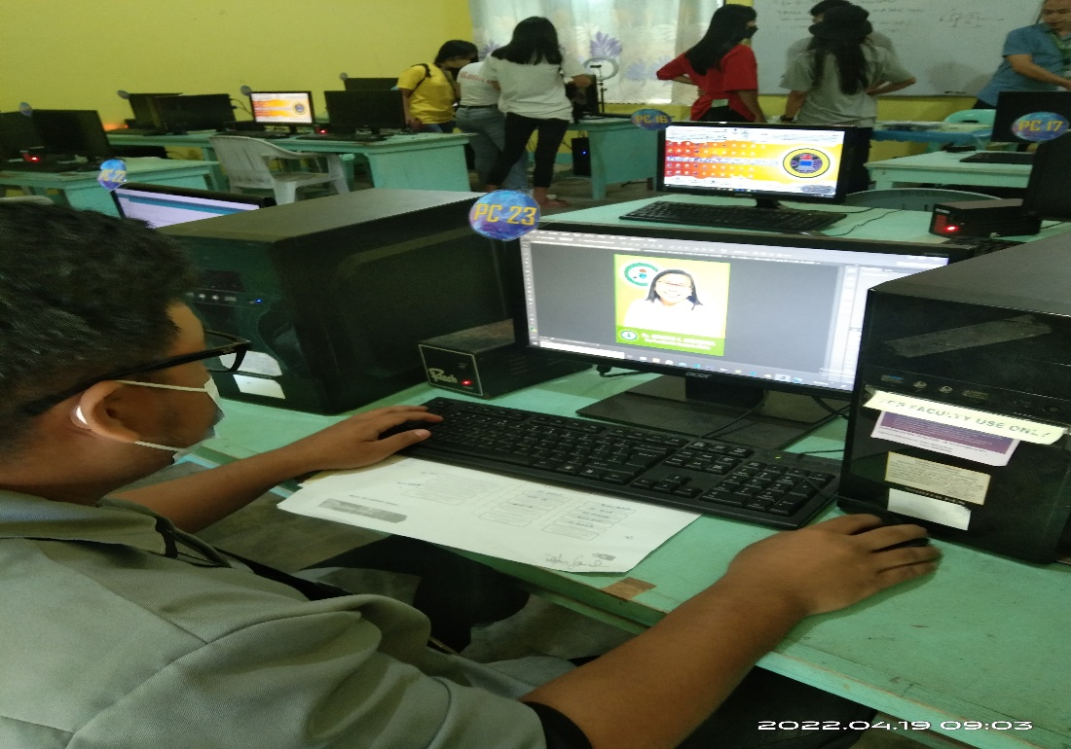

Creating a layout for the Organizational Chart

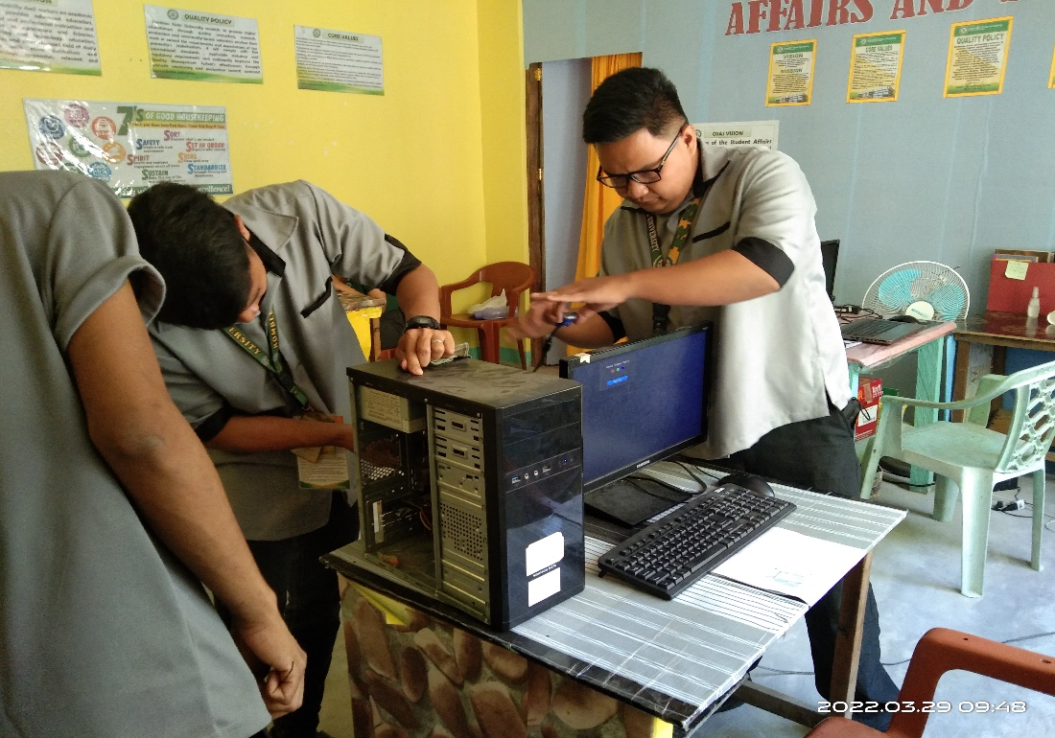

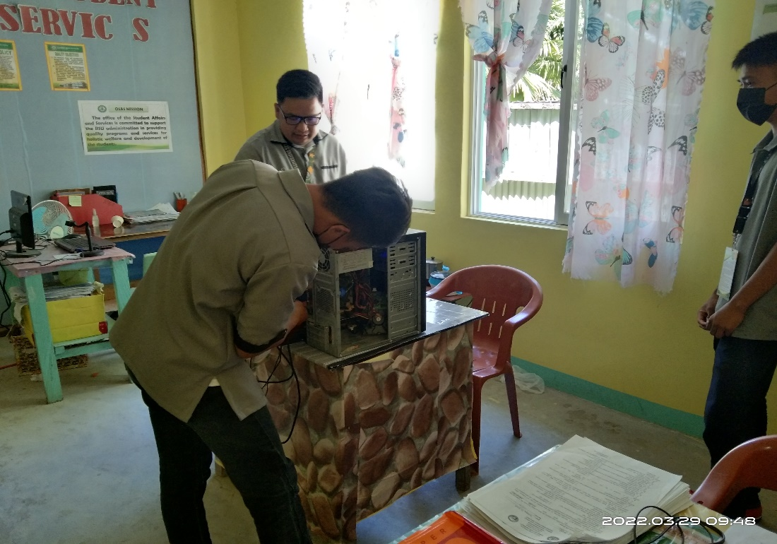

Troubleshooting a unit in the faculty office that has no display

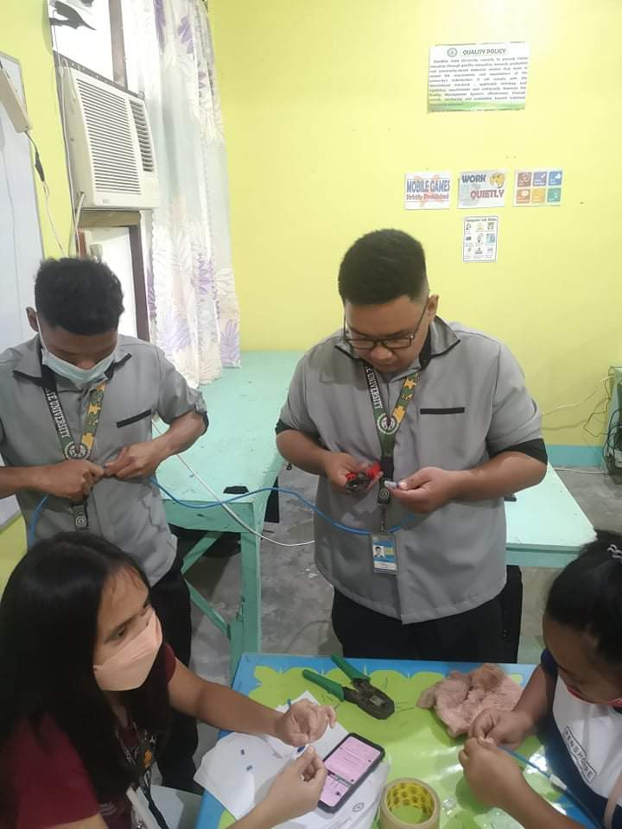

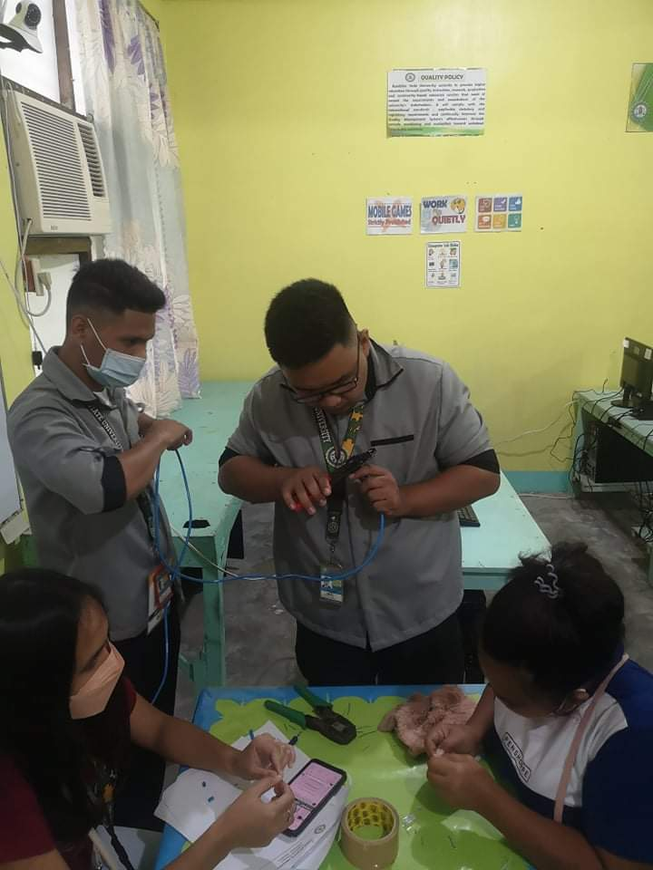

Creating LAN cable for Local Networks.

## APPENDIX D

**(Daily Time Record)**

## APPENDIX E

**(CURRICULUM VITAE)**



**ARTZ A. RASE**

Gutivan, Cajidiocan, Romblon

09389859883

artzrase2@gmail.com

**EDUCATIONAL ATTAINMENT**

**Tertiary:** Romblon State University

Sugod, Cajidiocan, Romblon

2018-2019

**Secondary:** Cajidiocan National High School

Poblacion, Cajidiocan, Romblon

S.Y. 2013-2014

**Primary:** Gutivan Elementary School

Gutivan, Cajidiocan, Romblon

S.Y. 2009-2010

**PERSONAL DATA:**

**Address:** Gutivan, Cajidiocan, Romblon

**Age:** 24

**Date of birth:** August 26, 1997

**Nationality:** Filipino

**Religion:** Roman Catholic

**Father’s Name:** Pedro Rase

**Occupation:** Fisher Man

**Mother’s Name:** Sylvia A. Rase

**Occupation:** Housewife

**CHARACTER REFERENCES**

**DR. CARMELINDA M. JUANZO**

Campus Director

Romblon State University

Cajidiocan Campus

Sugod Cajidiocan, Romblon

**PROF. ROSEMIN F. RABIDA**

Campus Registrar

Romblon State University

Cajidiocan Campus

**PROF. CHITO F. JUANZO**

Assistant Professor I

I hereby certify that the above information are true and correct as to the best of my knowledge.

ARTZ A. RASE